Aufgabe 1
a)

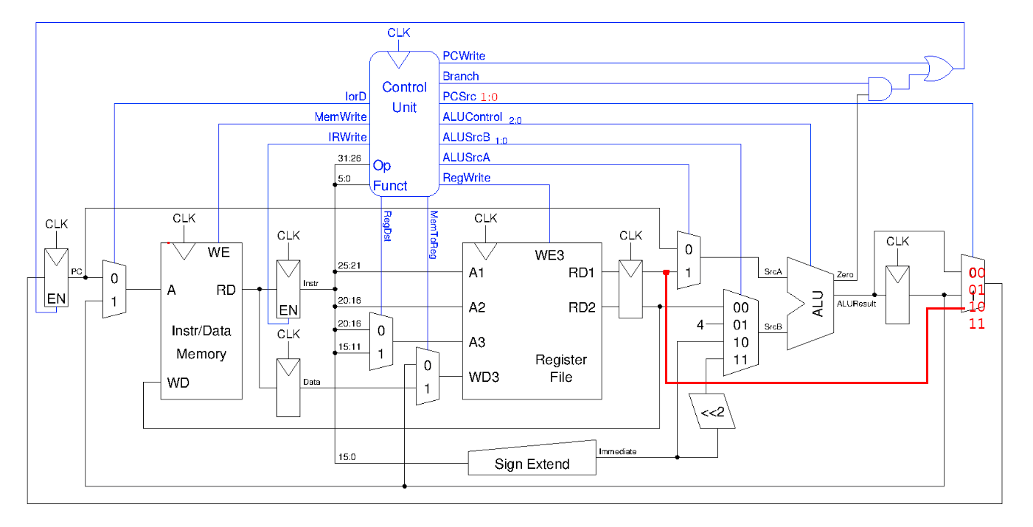

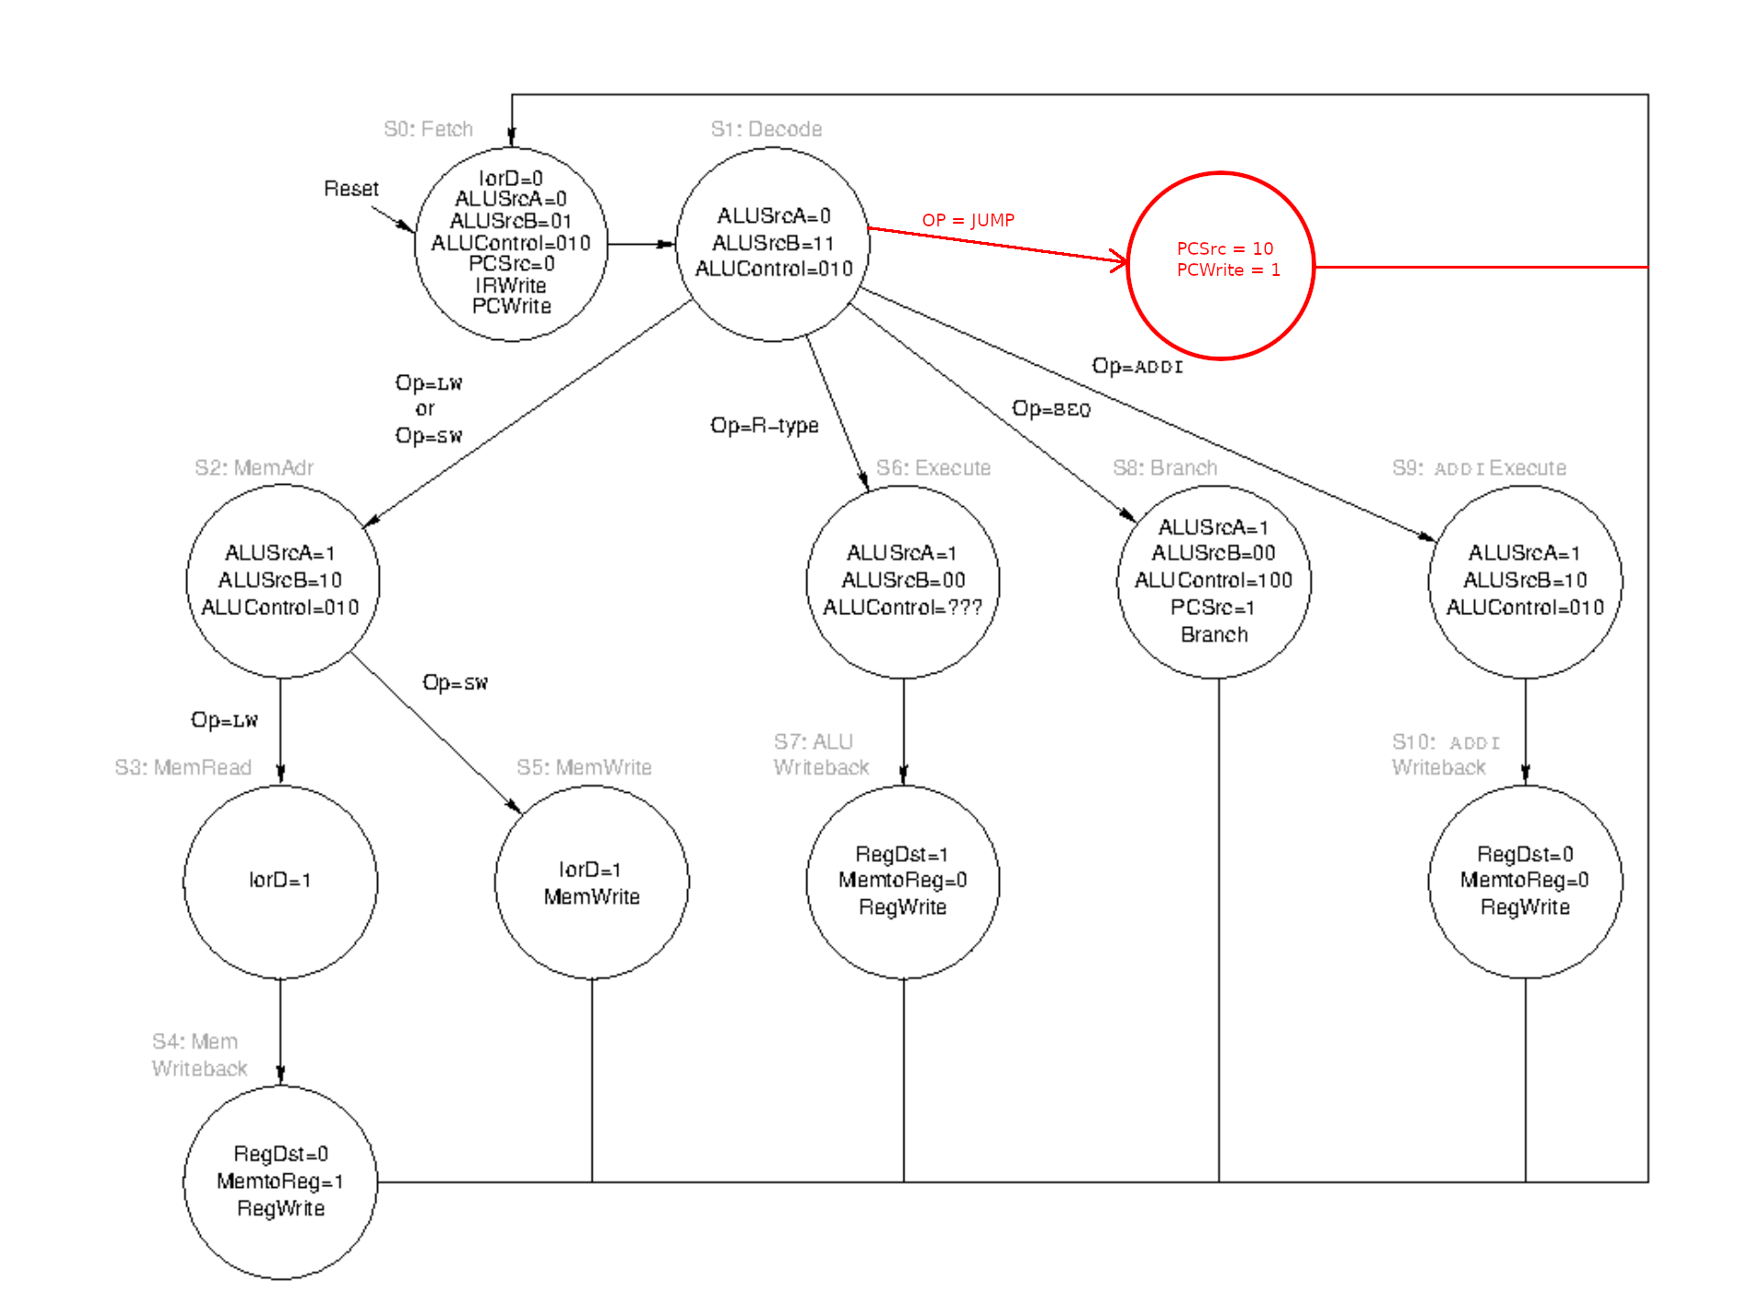

b)
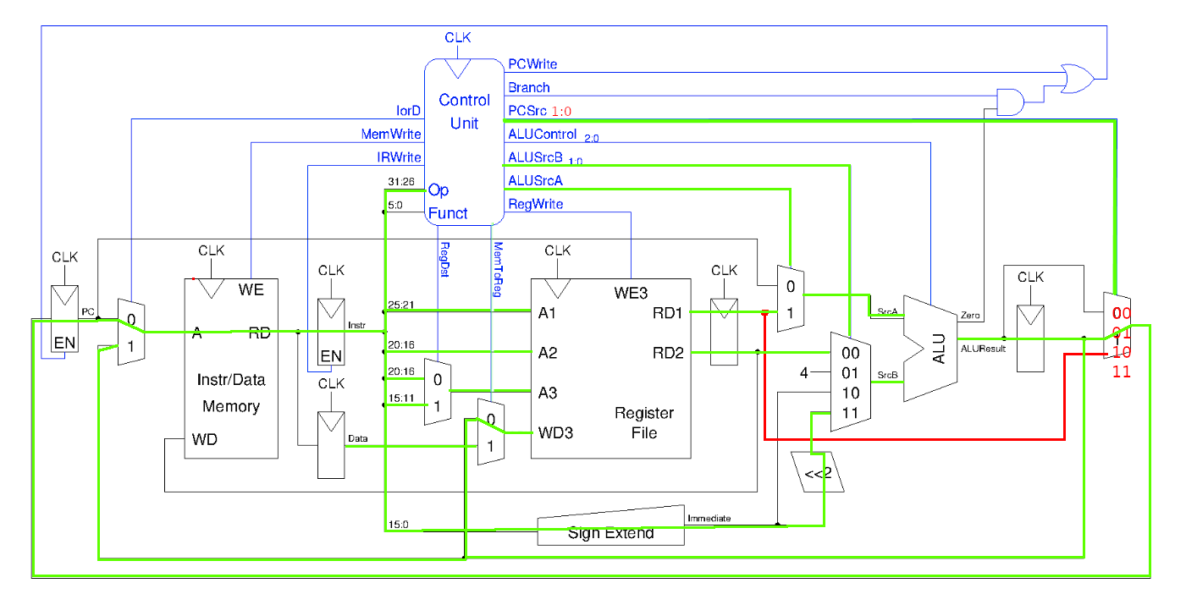

2-1 Mux: 50ps

Instruktionsspeicher: 250ps

Parallel: 30ps
CU: 0ps
2-1 Mux: 30ps
2-1 Mux: 30ps

Register: 40ps

Parallel: 50ps
2-1 Mux: 30ps
4-1 Mux: 50ps

ALU: 175ps

4-1 Mux: 50ps

c)

Sequentiell
2-1 Mux: 50ps

Instruktionsspeicher: 250ps

Parallel: 30ps
CU: 0ps
2-1 Mux: 30ps
2-1 Mux: 30ps

Register: 40ps

Parallel: 50ps
2-1 Mux: 30ps
4-1 Mux: 50ps

ALU: 175ps

4-1 Mux: 50ps

Zeit pro Takt:
50 + 250 + 30 + 40 + 50 + 175 + 50 = 645ps

Takt pro Sekunde:
1550387596.9 Hz =
1550387,596 KHz =
1550,387 MHz =
1,550 GHz

Kombinatorisch:
Parallel: 250ps
Instruction Memory: 250ps
Addierer: 125ps

Register File: 140ps

2-1 Mux: 30ps

ALU: 175ps

Data Memory: 220ps

2-1 Mux: 30ps

2-1 Mux: 30ps

2-1 Mux: 30ps

Zeit pro Takt:
250 + 140 + 30 + 175 + 220 + 30 + 30 + 30 = 905ps

Takt pro Sekunde:

1104972375.69 Hz =
1104972,375 KHz =
1104,974 MHz =
1,104 GHz

Unterschied: 0,446 GHz

